

WESTERN BALKANS SALW CONTROL ROADMAP
MULTI-PARTNER TRUST FUND

Narrative Annual Progress Report
January 2025 – December 2025

Project Title & Project Number |  |  | Country, Locality(ies), Priority Area(s) / Strategic Results
- Project Title: Advancing the Forensic Capacities of the Police Directorate of Montenegro for processing Firearms and Explosives-related Crimes.  - Project Number: 01001578  - MPTF Office Project Reference Number: 140474 |  |  | (if applicable)  Country/Region RBEC
Priority area/ strategic results

SALW Control Roadmap – Goals 2 and 3
Participating Organization(s) |  |  | Implementing Partners
- UNDP Country Office Montenegro |  |  | - Ministry of Interior/Police Directorate/Forensic Center of Montenegro
Project Cost (US$) |  |  | Project Duration
Total approved budget as per project document:  MPTF /JP Contribution:  - by Agency (if applicable) | 1,391,105 |  | Overall Duration | 37 months
Agency Contribution  - by Agency (if applicable) |  |  | Start Date | 28 November 2023
Government Contribution  (if applicable) |  |  | Original End Date | 22 November 2025
Other Contributions (donors)  (if applicable) |  |  | Current End date | 31 December 2026
TOTAL: | 1,391,105
Project Assessment/Review/Mid-Term Eval. |  |  | Report Submitted By
Assessment/Review - if applicable please attach  Yes No Date: dd.mm.yyyy  Mid-Term Evaluation Report – if applicable please attach  Yes No Date: dd.mm.yyyy |  |  | - Name: Gordan Ivanovic  - Title: Programme Manager  - Participating Organization (Lead): UNDP  - Email address: gordan.ivanovic@undp.org

I. Background
The project aims at improving the crime scene investigation and laboratory forensic capacities of the Police Directorate of Montenegro for providing forensic evidence and intelligence necessary for investigating and judicial processing the trafficking of firearms, their ammunition, explosives, and precursors, as well as other FAE-related criminal offences, including the sexual and gender-based violence. Improved evidence and intelligence capabilities shall serve the national criminal proceeding system and international investigations and proceedings. The project will do it by procuring equipment, delivering training, developing, and validating new methods, and developing standard operating procedures. The focus will be on standardizing work processes in accordance with the policy and recommendations of the European Network of Forensic Science Institutes and preparing for accreditation in line with ISO/IEC 17025 and 17020 international standards. This implies implementation of project standardization results in the regulatory framework of the Ministry of Interior of Montenegro, thus providing sustainability of project’s results.
Crime scene investigation (CSI) requires a significant upgrade in Montenegro, as recognized by the gap analysis conducted within the first project and repeatedly explained by the beneficiary during that period. CSI is doubtlessly the highest priority regarding improvement needs since it represents the principal origin of physical evidence for FAE-related crimes, and it is not nearly as developed as forensic laboratory capacities in Montenegro. An integral intervention in this area cannot currently be proposed because of the ongoing territorial reorganization of the Police Directorate, which includes CSI, and the limited project possibilities regarding budget and time. For example, the CSI case management system, representing one of the most important needs that would support the integrity and continuity of evidence and the chain of custody, was considered with the beneficiary. Due to the reasons explained above and the information provided by the FC that there is a possibility for such a system to be financed from other sources, it was not included in the proposal. In this area, the previous project concentrated on developing relevant SOPs and on implementing new CS documenting methods (3D scanning, aerial photography), including equipment purchase, mainly for the FC CSI Unit. Since most FAE-related crimes committed in Montenegro are processed by the Podgorica and FC CSI units, the focus was on providing the Regional Centres for Crime Scene Investigation with priority equipment and training for implementing advanced methods for finding and collecting relevant evidence and simultaneous implementation of security measures for the personnel.
Within the forensic response regarding tackling sexual and gender-based violence (SGBV), including domestic violence, another room for improvement was recognized. The previous project provided training to relevant CSI officers on forensic processing of SGBV crime scenes. This project will work on awareness raising about improved inter-institutional cooperation modalities for providing more diverse and valid forensic evidence for such types of crime. Relevant stakeholders will be included, such as criminal police, crime scene, and laboratory-forensic investigators, prosecutors, and medical, social, civil and non-governmental sector representatives. New methods will also be introduced regarding forensic documenting of victims’ injuries and retrieving information essential for CSI from victims, avoiding secondary victimization.
Ballistic investigations still need to be accredited in Montenegro, and the FC is investing strenuous efforts in this area, supported by OSCE. The previous UNDP Montenegro project conducted an ISO/IEC 17025 accreditation awareness-raising training, among others for the ballistic lab staff. The proposed project will focus on supporting FC in the accreditation endeavour through equipment, training, ensuring security for the personnel manipulating firearms, and financing quality maintenance activities complementary to OSCE support. OSCE contributed by facilitating expert support from North Macedonia, whose ballistic lab is already accredited. The project will concentrate on contributing to accreditation preparatory activities by replacing the shooting backstop and providing a multifunctional device for the safe discharging of firearms and a ballistic radar (to improve security and operability), and by providing necessary proficiency test, training internal auditors, a participating ballistic lab staff members in international expert events, such as ENFSI Firearms/GSR Working group. This intervention aligns with relevant SALW Strategy goals and AP key measures and therefore represents a priority.
The project will build upon and further develop previous interventions in the area of explosives/explosive devices physical expert examinations where a number of SOPs were developed, and the lab integrally supported in carrying out accreditation preparation activities. Personnel health care and security will be improved, as well as some previously established methods, by additional equipment and materials. Accreditation will be further supported by establishing and validating a new method and providing some equipment in line with SALW Strategy and AP. Since explosives impose a high-level threat to Montenegrin society, as explained above, an adequate forensic response in this area is required.
The activities regarding improving FC chemical analytical capacities for explosives, their forensic traces, GSR, etc., will build on previous project results. A new explosives-investigating method was introduced and prepared for accreditation, including purchase of key equipment, SOP development, method validation, training, etc. Equipment will be significantly upgraded, and expert support provided, allowing further methodology improvements, development, and validation of a new method, contributing to an extended accreditation scope (in line with SALW Strategy and AP). The project will also engage international expert(s) for standardizing analytical and anti-contamination procedures. Similarly, to the explosives/explosive devices physical expert examinations (see previous paragraph), the planned chemical lab improvements will additionally contribute to probative capacities improvements regarding explosives-related crimes.

II. List of Acronyms

AP Action plan
CSI Crime Scene Investigation
ENFSI European Network of Forensic Scientific Institutes
FC Forensic Center
FAE Firearms, Ammunition and Explosives
GSR Gun Shot Residues
OCF Open Case File
OSCE Organization for Security and Co-operation in Europe
SALW Small Arms and Light Weapons
SOP Standard Operational Procedures
SGBV Sexual and Gender-Based Violence

III. Executive Summary

The following represents an overview of the implementation of the activities under this Project, for the period January 2025 –December 2025.

During the reporting period, significant progress has been achieved in strengthening the operational, technical, and investigative capacities of the Forensic Centre and the Police Directorate (PD). Five Standard Operating Procedures (SOPs) were finalized in close collaboration with forensic professionals and formally approved. Capacity-building efforts included specialized trainings on advanced equipment such as drones, 3D scanners, and Crime Lite Auto devices, alongside internal auditor training for eight forensic experts. International engagement was reinforced through participation in key ENFSI conferences and workshops, while 14 crime scene investigation (CSI) officers received advanced training on ISO/IEC 17020 standards. Planning has also been completed with partners to expand CSI capabilities across regional centers.
In parallel, targeted improvements were made in investigative methodologies. Existing interviewing procedures were analyzed, and a protocol for handling sexual and gender-based violence (SGBV) cases was developed. A specialized training on injury documentation during medical examinations was delivered to seven police officers, enhancing the quality and consistency of forensic medical reporting.
Technical capacities in ballistic and explosives analysis were further upgraded. New equipment, including a multifunctional firearm discharge device and optical fibre testing tools, was delivered, accompanied by supplier-led trainings. Ballistic procedures and documentation were comprehensively reviewed and improved, resulting in updated SOPs, the introduction of Evofinder procedures, and a bilingual glossary to strengthen traceability and international cooperation. Proficiency testing for ballistics experts is ongoing.
Advancements were also made in fire, explosives, and chemical analysis. New storage infrastructure for explosives was installed, and a novel method for examining fuse correctness—along with its SOP—was developed and validated. In the chemical laboratory, a new GC-MS-based method for qualitative TNT detection was successfully developed and validated, further enhancing analytical capabilities.
Finally, the delivery of a Scanning Electron Microscope (SEM) significantly strengthened gunshot residue (GSR) analysis capacity. Specialized training was conducted, and a validation plan for SEM/EDS-based GSR testing has been prepared, with implementation scheduled for Q1 2026. A draft SOP for SEM operations has also been completed and is expected to be finalized within the same timeframe.
The project organized a study visit for the Forensic Center professionals to the National Forensic Laboratory in Ljubljana, Slovenia, from 16-17 June 2025. A team from the Forensic Center, including Head of the Forensic Center of Montenegro and experts in Gun Shot Residues, fire/explosion investigations, chemical, and ballistic, participated at the study visit. The programme involved detailed visits to key departments including: the department for physical examinations, chemical examinations, biological examinations, ballistics and the department for quality and laboratory development with focus on the work on traces from fires, explosions, pyrotechnics, etc. The participants examined the advanced equipment used for examinations such as chromatography and Raman and exchanged experience on forensic analyses related to ballistics and explosives specifically. In the physical examination department, Gun Shot Residues analysis was demonstrated using a Thermo Fisher Quatro Scanning Electronic Microscope. Participants also observed firearms discharge distance testing, trace analysis from locks, footwear, and fire/explosion investigations, along with applied software solutions. The visit was highly beneficial, enhancing professional exchange and paving the way for future collaboration with Slovenian forensic experts.

Outcome 1 Improved overall Crime Scene Investigation (CSI) capacities in Montenegro for investigating FAE-related crime, encompassing SGBV criminal cases aims to enhance the capability of the CSI service of the Police Directorate to recover evidence for judicial proceedings of (primarily) mentioned types of criminal offences.
Output 1.1: Improved staff security and capacities in the on-site forensic investigation of explosives-related criminal cases and implementation of QMS and advanced methods for visualizing specific forensic evidence.
Output 1.2: Advanced methodologies for CSI processing of SGBV criminal cases as related to firearms.
Output 1.3: Support to the mobility of the CSI units and upgrade of facilities for CSI units across the jurisdiction

Outcome 2 Improved ballistic capacities of the Forensic Centre aim to support the preparation of the Ballistic Laboratory of the Forensic Centre in preparing for ISO/IEC 17025 accreditation, in terms of SOPs, quality assurance activities, health care and security, and new equipment.
Output 2.1: Improved security and advanced preparation of the Ballistic Laboratory for ISO/IEC 17025 accreditation.

Outcome 3 Improved capacities of the Arson and Explosives Lab for physical examination of explosives/explosive devices aim to support this lab in extending the methodology and assuring the security of personnel and property while handling and storing explosives.
Output 3.1: Advanced security and operability and extended scope of accreditation within the Arson and Explosives Lab.

Outcome 4 Improved capacities of the Chemical Lab for chemical examination of explosives and GSR aims to support this lab in extending the methodology for chemical expert examinations of explosives and post-blast traces, as well as gunshot residues.
Output 4.1: New methods and procedures for analyzing explosives developed, and the scope of ISO/IEC 17025 accreditation for expert examination of explosive samples/traces extended.
Output 4.2: Improved Gunshot residue (GSR) analysis capacities.

Brief contextual analysis
Overall, the project has been implemented with no major challenges and in a conducive environment during the reporting period. Out beneficiary the Forensic Center of Montenegro has proved to be very devoted for the work on the project which has great influence on the success of the project results. UNDP has new counterparts from the Criminal Police Dept in the Ministry of Interior/Police Directorate who are very much supportive.

Budget implementation
The project’s budget has been utilized as planned during the reporting period, with the total project’s expenditure by the end of the reporting period of USD 896,596.

Further details in the relevant sections of the report and the annexed provisional financial report.

IV. Overview of progress towards results (for Annual and Final Reports only)
This table should cover the entire project implementation period.

Project Outcome | Project Outcome Indicators | Target | Status of project results  (please select one of the following options: [result] achieved/ partially achieved/ not achieved/ activities not initiated) | Achievements against indicators and targets
Outcome 1: Improved overall CSI capacities in Montenegro for investigating FAE related crime, encompassing SGBV criminal cases | 1.1.1.  Number of post-blast crime scenes attended with an explosive detector during 12 months | 1.1.1.  10 post-blast CSIs | Result achieved | 10 post-blast CSI activities
 | 1.1.2.  Number of fingerprints and micro-traces detected/captured/collected by utilizing the purchased device during 12 months | 1.1.2.  50 trace evidence | Result achieved | After completing the SOP, training was delivered in June 2025. During the device’s 6 months of operational use, 304 traces/fingerprints have been recovered.
 | 1.1.3.  Number of new SOPs on CSI | 1.1.3.  10 SOPs | Result partially achieved | 5 SOPs developed  (Additional SOPs are planned for development during 2026).
 | 1.1.4.  Number of CSI officers trained on an advanced level for 3D scanning and aerial photography crime scene documenting | 1.1.4.  14 trained forensic/CSI officers | Result partially achieved | 11 trained forensic/CSI officers  (Additional training courses are planned during 2026).
 | 1.1.5.  Number of CSI officers trained on an advanced level on practical aspects of ISO/IEC 17020 in CSI, evidence custody chain, packaging, and tagging, case-management solutions, and application of the SOP | 1.1.5.  20 trained CSI officers | Result partially achieved | 14 trained CSI officers
 | 1.1.6.  FC representatives participated in ENFSI SOC Working Group (WG) meetings, in regional peer exchange (RPE), and in international study visits (SV) in 2024, 2025 and 2026 | 1.1.6.  Successful participation  [for ENFSI: FC rep.(s) involved in at least one SOC WG activity.  for SVs: specific relevant knowledge gained (stated in the activity report).  for RPE: at least one relevant joint task established and jointly processed.] | Result partially achieved | Participation at the ENFSI workshops and Study visits
 | 1.2.1.  Two successfully delivered multisector panels | 1.2.1.  Positive evaluations by all stakeholders (4+) | Result not achieved | TORs for consultants are published, and the panels are planned for 2026.
 | 1.2.2.  Number of CSI officers trained in documenting injuries on victims during medical examinations | 1.2.2.  8 trained CSI officers | Result achieved | 7 trained officers
 | 1.2.3.  The protocol developed on interviewing techniques for CSI officers in 2024 | 1.2.3.  Protocol accepted by the beneficiary | Result achieved | Protocol finalized
 | 1.2.4  Number of CSI officers trained in protocol implementation | 1.2.4  20 trained CSI officers | Activities not initiated | The same consultant (see 1.2.3.) will deliver the training in March 2026.
Outcome 2: Improved ballistic capacities of the Forensic Centre | 2.1.1.  The laboratory and shooting range additionally equipped/refurbished till 2025 | 2.1.1.  Shooting range and gunsmith workshop fully operational | Result achieved | Shooting range and gunsmith workshop refurbished based on the project design developed and furniture provided
 | 2.1.2  Proficiency test successfully completed by FC ballistic lab in 2025 | 2.1.2  1 successful PT | Result achieved | PT was delivered and completed
 | 2.1.3.  Number of forensic experts trained as internal auditors in 2025 | 2.1.3.  3 trained forensic experts | Result achieved | 8 forensic experts trained
 | 2.1.4.  FC representatives participated in ENFSI Firearms/GSR Working Group meetings, in EAFS, in regional ballistic expert peer exchange, and in international study visits on ballistic labs in 2024, 2025 and 2026 | 2.1.4.  Successful participations  [for ENFSI: FC rep.(s) involved in at least one Firearms/GSR WG activity.  for SVs: specific relevant knowledge gained (stated in the activity report).  for RPE: at least one relevant joint task established and jointly processed.] | Result partially achieved | Participation at the ENFSI workshops and Study visits
 | 2.1.5.  Number of new SOPs on ballistic methods (OCF, ABIS, and illegal firearms systems) | 2.1.5.  3 new SOPs | Result achieved | 3 SOPs
Outcome 3: Improved capacities for physical examination of explosives/explosive devices. | 3.1.1.  - Equipment for improving health care and security purchased and installed;  - Number of transported explosive samples during 12 months;  - Quantity of stored explosives during 12 months | 3.1.1.  20+ samples transported and 10kg+ of explosives stored. | Result achieved | 11 kg of explosives were stored in 2025.  More than 20 samples were transported in 2025.
 | 3.1.2.  The new method selected during assessment (out of the following: reviewing conventional explosive devices, reviewing improvised explosive devices, examining the correctness of the fuse regarding spark transfer, and burning velocity, etc.) developed and validated | 3.1.2.  The new method implemented | Result achieved | The new method was developed and validated.
 | 3.1.3.  FC representatives participated in ENFSI Fire/Explosions Working Group meetings, in regional peer exchange with AE experts, and in international study visits to institution(s)/lab(s) in charge of physical examinations of explosives/explosive devices and explosions in 2024, 2025 and 2026 | 3.1.3.  Successful participations  [for ENFSI: FC rep.(s) involved in at least one Fire/Exp. WG activity.  for SVs: specific relevant knowledge gained (stated in the activity report).  for RPE: at least one relevant joint task established and jointly processed.] | Result partially achieved | Participation at the relevant ENFSI workshops and Study visits
Outcome 4: Improved capacities for chemical examination of explosives and GSR | 4.1.1.  Chemical lab equipment for implementing the new method for chemical examination of explosives | 4.1.1.  Equipment put into operation | Result achieved | Equipment procured and delivered
 | 4.1.2.  Number of SOPs for processing explosives and traces and for anti-contamination measures developed | 4.1.2.  2 SOPs | Result not achieved | No candidate applied for the consultancy tender. FC experts will develop the SOPs independently, leveraging knowledge gained from project activities and participation at the ENFSI workshops.
 | 4.1.3.  The new method for chemical examination of explosives (traces) developed and validated | 4.1.3.  The new method implemented | Result achieved | The new method was developed and validated.
 | 4.1.4.  FC representatives participated in ENFSI Explosives Working Group and in ENFSI annual meetings of directors, in regional peer exchange with chemical experts in explosives, and in international study visits to forensic chemical lab(s) analyzing explosive samples in 2024, 2025 and 2026 | 4.1.4.  Successful participation  [for ENFSI: FC rep.(s) involved in at least one Explosives WG activity.  for SVs: specific relevant knowledge gained (stated in the activity report).  for RPE: at least one relevant joint task established and jointly processed.] | Result partially achieved | Participation at the ENFSI workshops and Study visits
 | 4.2.1.  GSR lab equipment purchased | 4.2.1.  Equipment put into operation | Result achieved | Equipment purchased and installed
 | 4.2.2.  Number of SOPs based on the new equipment revised | 4.2.2.  2 SOPs | Result partially achieved | The consultant has been contracted and activities ongoing.
 | 4.2.3.  The new method for advanced GSR analysis developed and validated | 4.2.3.  The new method implemented | Result partially achieved | The consultant has been contracted and activities ongoing.

IV. Progress review

Output 1.1: | Improved staff security and capacities in the on-site forensic investigation of explosives-related criminal cases and implementation of QMS and advanced methods for visualizing specific forensic evidence
Total budget: | $ 380,535 | Spent: | $ 133,376

1. Progress towards the output
Building upon previous interventions carried out in the framework of the first project, the current project will further support the crime scene investigation units in addressing the gaps identified during the previous project primarily through development of up-to-date procedures, trainings of the staff and purchase of the required equipment. In addition to analyses of CSI capacities in Montenegro carried out so far and available reports and recommendations, the project will provide a targeted expert needs analysis in this area to precisely recognize the most actual needs in more details than presented in the project proposal from the perspective of the Project’s overall objective.

- In 2025 5 SOPs have been finalized by the consultant in close cooperation with the professionals from the Forensic Center and approved through internal procedure of the Forensic Center. Trainings finalized for professionals from Forensic Center in using drone, 3D scanner and Crime Lite Auto device. Two Forensic Centre representatives attended the ENFSI Conference in The Hague (23–25 September 2025). Advanced training on applying ISO/IEC 17020 to crime scene investigation was delivered to 14 Montenegrin CSI officers within a project framework by forensic consultant. Initial planning finalized with partners as per cost extension from the Police Directorate (PD) for organizing and delivering the activities that aim to improve further the capacities of the PD CSI line of work in the Regional Centers

2. Description of activities implemented during the reporting period

Activity 1.1.1: Development of SOPs, specialized training, and knowledge-exchange for on-site forensic investigation.
- During the reporting period expert hired to work on development of SOPs has finalised SOPs in close consultations with beneficiaries. Following SOPs have been finalised:
- a) SOP/WI on CSI documentation by utilizing the 3D laser scanning technique.
- b) SOP/WI on CSI documentation by utilizing aerial photography.
- c) SOP/WI on forensic evidence recovery by utilizing the Crime Lite Auto device.
- d) SOP/WI on searching, locating, collecting, and further handling of firearms and other ballistic evidence. Such a procedure should contain a definition and general information about this evidence type, including categorization (e.g., ballistic evidence on victims, on perpetrators, on the scene), instructions for searching for such types of evidence on the scene, and on objects, proper collecting, preserving, etc.
- e) SOP/WI on protecting (packing) evidentiary items at the scene, marking them following the unique identity principle, and establishing and maintaining the custody chain.

- CSI consultant developed a curriculum and delivered advanced training (5 days) on operating the drone, recording images and videos, processing the captured digital material, and creating CSI documentation, which was based on the SOP. During the previous project, basic drone training was provided to the staff of the Forensic Center. A total of 6 CSI officers and forensic experts (2 women and 4 men) have been trained to apply this new method in practice, thereby enhancing the evidentiary capacity of the Forensic Center. Forensic aerial photography involves capturing photographs and video footage from the air, typically using a drone with a camera, to document scenes for criminal investigations. These aerial images offer a unique overhead perspective, revealing important clues that are often difficult to see from the ground. This method is particularly useful for documenting large or hard-to-reach areas, such as open-air explosions, crimes involving many firearms, or accidents involving hazardous substances.

- Introduction of another digital crime scene documentation method—laser 3D scanning—was initiated in previous project phase by acquiring an appropriate device, providing basic training, and writing an SOP for using the device. During 2025, a curriculum was developed, and a five-day advanced training was conducted by the consultant for five participants—CSI officers and forensic experts (1 woman and 4 men). The 3D scan documentation method enables avoiding doubts that may arise during the process of determining the exact location of specific evidence—particularly when the crime scene has been changed or no longer exists as such—and especially when there are opposing interests regarding the precise measurements and distances of the evidence between parties in criminal proceedings. This type of digital recording, with the aid of suitable software, enables the analysis and creation of both two-dimensional and three-dimensional representations of the site. Importantly, it provides accurate positions and measurements related to the evidence and other visible details at the scene. The advantages of this method include the extensive information that can be easily stored, permanently preserved, and materialized, as well as reducing the risk of human error affecting the accuracy of the documented data.
- The consultant finalized a curriculum and conducted a two-day training (also based on the previously developed SOP) for using the Crime Lite Auto device at crime scenes for 12 CSI officers and forensic experts (7 women and 5 men). This enables contactless searching, detection, and preservation of latent fingerprints and other traces (fibers, biological traces, GSR, etc.) on complex surfaces, including firearms and components of explosive devices. As a result, fingerprints, and biological traces—key biometric identifiers—and many other micro traces will be recovered much more effectively, while potentially present biological material, especially sensitive DNA traces, will remain fully protected from contamination.
- Two Forensic Centre representatives attended the ENFSI Conference in The Hague (23–25 September 2025) ENFSI Scene of Crime 2025 | Foster+Freeman , gaining insights into crime scene investigation and bloodstain analysis practices across Europe. Key topics included investigative organization, crime scene visualization, timeline tracking, bloodstain analysis standardization, and technological tools such as 3D scanning and portable body fluid detectors.
- The ENFSI Scene of Crime event is a leading forum for professionals involved in the crucial first step of forensic science; crime scene investigation. Organized by the ENFSI Scene of Crime Working Group, the event emphasizes the vital role of the crime scene in the broader context of forensic science, criminal investigation, and the administration of justice. Recognizing that “crime scene” encompasses not only physical locations but also the collection and interpretation of evidence from suspects and victims, the event embraces a comprehensive and inclusive approach. With participation reflecting the diverse interests of police, forensic experts, and law enforcement agencies, the ENFSI Scene of Crime event offers a unique platform to share expertise, explore new techniques, and strengthen collaboration across borders to advance the effectiveness and integrity of crime scene examination. The conference also introduced the latest ENFSI best practice manuals and facilitated plans for collaboration with the Finnish team using shared equipment and software. A study visit to Dutch National Forensic Institute laboratories provided firsthand observation of DNA, trace, and biological evidence processing. The conference enhanced professional knowledge, strengthened international contacts, and materials will be shared with the PEU group for application in national practice.
- Advanced training on applying ISO/IEC 17020 to crime scene investigation was delivered to 14 Montenegrin CSI officers (male) within a project framework by forensic consultant. The training emphasized the practical implementation of ISO/IEC 17020 and ILAC-G19 guidelines, focusing on standardization, impartiality, documentation, quality assurance, evidence packaging and labelling, chain of custody, and preservation of evidence integrity. A major component addressed firearms and ballistic evidence, including weapons, ammunition, GSR, and trajectory-related damage. The course combined theoretical instruction with interactive discussions, case studies, demonstrations, and extensive hands-on exercises in realistic crime scene scenarios. Using an andragogical, practice-oriented approach, the training strengthened forensic competencies, improved compliance with international standards, and enhanced the credibility and evidentiary value of forensic work within the Montenegrin Police Directorate.

Activity 1.1.2: Provision of specialized equipment for on-site forensic investigation

- This activity was finalised in 2024.

Activity 1.1.3: Support to the mobility of the CSI units and upgrade of facilities for CSI units across the jurisdiction
- Initial planning finalized with partners from the Police Directorate (PD) for organizing and delivering the activities that aim to improve further the capacities of the PD CSI line of work in the Regional Centers

3. Difficulties encountered, and measures taken to overcome the problems

N/A

4. Changes introduced in implementation
N/A

5. Achievements

- 5 SOPs have been finalized by the consultant in close cooperation with the professionals from the Forensic Center and approved through internal procedure of the Forensic Center. Trainings finalized for professionals from Forensic Center in using drone, 3D scanner and Crime Lite Auto device. Two Forensic Centre representatives attended the ENFSI Conference in The Hague (23–25 September 2025). Advanced training on applying ISO/IEC 17020 to crime scene investigation was delivered to 14 Montenegrin CSI officers within a project framework by forensic consultant. Initial planning finalized with partners as per cost extension from the Police Directorate (PD) for organizing and delivering the activities that aim to improve further the capacities of the PD CSI line of work in the Regional Centers

6. Work plan for Q1 2026
Planned activities | Indicators | Budget (US$)
Hiring consultants as per cost extension | Contracts signed | 5,000

Output 1.2: | Advanced methodologies for CSI processing of SGBV criminal cases as related to firearms.
Total budget: | $ 40,350 | Spent: | $11,816

1. Progress towards the output
The project plans to promote strengthening of crime scene investigation link in the forensic chain of processing sexual and gender-based violence (SGBV) cases as related to firearms. Establishment of special CSI techniques in this area is of crucial importance. The project will raise awareness of relevant stakeholders on the benefits of using an advanced methodology for collecting forensic evidence during the medical examination of victims of SGBV. To this end, the project will offer multi-sector panel sessions that will examine solutions regarding implementation modalities in Montenegro. In addition, the project will support necessary training and the development of a protocol for dealing with SGBV cases.

- In 2025 Analyses of the existing interviewing techniques/procedures and Protocol developed for dealing with SGBV cases. Expert hired to prepare curriculum and lead training on documenting injuries on victims during medical examinations. Specialized training on injury documentation during medical examinations was delivered by a forensic trainer to 7 police officers (woman).

2. Description of activities implemented during the reporting period

Activity 1.2.1: Multi-sector Gender Based Violence (GBV) panels.
- Preparatory work is initiated, and contacts made with participating institutions for the GBV panels in cooperation with Gender team from the UNDP office. The training will follow finalisation of trainings under 1.2.2 and 1.2.3

Activity 1.2.2: Training on documenting injuries on victims during medical examinations
- Specialized training on injury documentation during medical examinations was delivered by a forensic trainer to 7 police officers (woman). Conducted under a project-developed curriculum, the training aimed to strengthen police capacity in responding to gender-based and domestic violence cases. It combined theoretical instruction with practical exercises in forensic photography and evidence documentation, with a strong focus on standardized procedures, proper use of digital photography, and effective cooperation with medical personnel to ensure legally admissible evidence. Participants were introduced to internationally recognized forensic standards and engaged in hands-on, scenario-based learning. Overall, the training enhanced professional competencies and promoted victim-centered, evidence-based police practice.

Activity 1.2.3: Protocol development and training on interviewing techniques for CSI officers
- Expert has finalised the analyses of the existing interviewing procedures and daily routines and identified the optimal solution for including CSI officers in interviewing procedures to retrieve information from victims relevant to the CSI of SGBV cases.
- A specialized SOP (Protocol) has been developed intended to precisely guide the CSI officer in the conversation with the victim, especially if firearms are involved, which will involve adequate psychological techniques for minimizing secondary victimization.
- A curriculum is designed for training to be organized on leading the communication by implementing the Protocol, with a particular accent on the victim-cantered approach for participants from CSI units.

3. Difficulties encountered, and measures taken to overcome the problems
- With regards to the training for CSI officers interviewing technics (1.2.3), the training was postponed to a later date in light of the limited number of officers Montenegro-wide and their busy schedule. The project team is working with the counterparts to assign a date that suits all. It will be organized in Q1 2026.

4. Changes introduced in implementation
N/A

5. Achievements
- Analyses of the existing interviewing techniques/procedures and Protocol developed for dealing with SGBV cases. Specialized training on injury documentation during medical examinations was delivered by a forensic trainer to 7 police officers (woman).

6. Work plan for Q1 2026
Planned activities | Indicators | Budget (US$)
Training in using Interviewing procedures protocol | Trainings finalised | 6,000

Output 2.1: | Improved security and advanced preparation of the Ballistic Laboratory for ISO/IEC 17025 accreditation
Total budget: | $ 90,418 | Spent: | $ 64,652

1. Progress towards the output
The critical forensic evidence utilized in processing firearms-related criminal cases (trafficking, gun-enabled crime, etc.) is obtained by expert examinations in ballistic laboratories. The results of the ballistic examinations are also used for firearms tracing, estimating the brand and model of an unknown firearm used in a crime, interconnecting different criminal cases by utilizing the Open Case File (OCF) collection, and many other purposes. The project will support the FC Ballistic Laboratory’s preparation for ISO/IEC 17025 accreditation, building upon the previous work where awareness of the accreditation requirements was raised among the ballistic experts. Before carrying out the activities, an assessment of the overall FC capacities for ballistic examinations, including OCF, will be performed, observing and complementing interventions already provided and planned, including ones supported by other international partners. Recommendations will be brought regarding activities supporting accreditation preparation, shooting range security, and purchasing equipment and potential IT solutions for the laboratory.

In 2025, Multifunctional device for safe discharging of firearms delivered to the Ballistic laboratory and training organized by the supplier for two (men) professionals. Training for internal auditors finalised for 8 forensic experts. Proficiency test being done by ballistics experts. Ballistic OCF procedures and technical documentation were reviewed and upgraded, resulting in revised standardized documentation, a new Evofinder SOP, and a bilingual glossary to improve traceability, system compatibility, and international cooperation was finalised.

2. Description of activities implemented during the reporting period

Activity 2.1.1: Supporting ISO/IEC 17025 accreditation preparation of the Ballistic Laboratory
- A company was contracted to deliver training for internal auditors. The ongoing extension of the Forensic Center’s ISO/IEC 17025 accreditation scope, aided by the UNDP project, necessitates training and certifying more internal auditors. By conducting a two-day training session for 8 forensic experts (5 women and 3 men), the internal auditing capacity of the Forensic Center has been significantly improved. Internal auditing, as a key tool for maintaining the Quality Management System (QMS) and thus the accreditation, is intended to verify that the QMS and work processes operate as planned, that the professional knowledge available is adequate, and that safety measures are in place.
- The ballistic proficiency test is conducted twice this year. The Forensic Center recently received the comparison material (cartridge cases) from the first test provided by the project, and ballistic experts will complete it and return the results to the test provider in the US. The second test (including bullets) is expected in late autumn this year.
- The activity involved reviewing and upgrading the procedures and technical documentation for the physical collection of ballistic Open Case Files (OCF) at the Forensic Center. This included aligning documents with OCF standards, new storage capacities, and the Evofinder automated ballistic system. During a field visit to the Forensic Center in Danilovgrad, meetings with management and ballistic laboratory experts assessed current practices and identified documentation needing revision or development. As a result, the existing OCF working instruction was comprehensively revised to improve standardization, traceability, and compatibility with laboratory infrastructure. Additionally, a new Standard Operating Procedure for the Evofinder system was developed, and a bilingual ballistic terminology glossary was prepared to support consistent terminology and international cooperation.
- A Ballistic professional (male) from the Forensic Center participated in the ENFSI Firearms & GSR EWG Annual Meeting October 1-3 ENFSI FAGSR Meeting 2025 | ENFSI The conference focused on international cooperation, crime scene reconstruction, and advanced ballistic analysis. Key topics included 3D-printed models in wound ballistics, differentiation between homicide and suicide, staged crime scenes, emerging threats such as 3D-printed firearms, and complex case reconstructions. A visit to the Netherlands Forensic Institute highlighted similarities in working conditions, with advantages stemming from greater staffing and experimental capacity. The workshop was highly beneficial for professional development, knowledge exchange, and exposure to modern forensic technologies.
Activity 2.1.2: Provision of specialized equipment for improving security and operability of the shooting range.
- Multifunctional device for safe discharging of firearms delivered to the Ballistic laboratory and training organized by the supplier for two (men) professionals.

Activity 2.1.3: Equipping and refurbishing the gunsmith workshop and the shooting range.
- Additional works on shooting range have been contracted to be finalized in Q1 2026

3. Difficulties encountered, and measures taken to overcome the problems
N/A

4. Changes introduced in implementation
N/A

5. Achievements
Multifunctional device for safe discharging of firearms delivered to the Ballistic laboratory and training organized by the supplier for two (men) professionals. Training for internal auditors finalised for 8 forensic experts. Proficiency test being done by ballistics experts. Ballistic OCF procedures and technical documentation were reviewed and upgraded, resulting in revised standardized documentation, a new Evofinder SOP, and a bilingual glossary to improve traceability, system compatibility, and international cooperation was finalised.

6. Work plan for Q1 2026
Planned activities | Indicators | Budget
Additional works on shooting range | Works finalised | 8,000

Output 3.1: | Advanced security and operability and extended scope of accreditation within the Arson and Explosives Lab
Total budget: | $ 86,696 | Spent: | $ 77,599

1. Progress towards the output
The FC capacities for physical examination of explosives and explosive devices have been significantly improved during the previous project by supporting the preparation for ISO/IEC 17025 accreditation and the establishment of proper and safe capacities for such kind of expert examinations exposed to specific security risks. The current project will further support the operability of the FC’s Arson and Explosives lab and the overall security in line with the ISO/IEC 17025. A new method will be developed and validated. The equipment for safe handling of explosives will be improved by purchasing additional storage containers and safety boxes (modules) for transporting explosives. Health care will be improved by purchasing and installing first aid kits. Operability in examining detonation velocity will be additionally supported by providing a specialized device for testing optical cables, as well as some consumable material.

- In 2025, Optical fiber tester, Optical extension cable and Fixing strip delivered to the A&E lab delivered to the A&E lab. TOR for expert for method development and its validation finalized. 2 Storage containers delivered to the Forensic Center which enabled safe storage of explosives. A Forensic professional of the Forensic Centre participated in the ENFSI Conference on fire and explosion investigations. Expert developed a new method - the examination of fuse correctness with respect to burning velocity and spark transfer including relevant Standard Operation Procedure in close cooperation with the professionals from the Arson and Explosives lab and finalized its validation.

2. Description of activities implemented during the reporting period

Activity 3.1.1: Method development, validation and additional support to accreditation
- A Forensic professional of the Forensic Centre participated in the ENFSI Conference on fire and explosion investigations held in Brussels (8–11 September 2025) 26th ENFSI Fire and Explosion Investigation Working Group Annual Meeting - European Forensic Institute. The event brought together European experts to exchange experiences and review best practices.
Key topics included the identification and analysis of improvised explosive devices, examination of evidence from fire scenes, and the use of digital electricity meter data in investigations. Practical experiments demonstrated causes of spontaneous combustion and fires from cigarette butts. The Best Practice Manual for post-incident scene work was revised and adopted, and the FIRMS (NASA) system for real-time fire monitoring was presented. The conference facilitated valuable networking with regional and EU experts, and materials from the sessions will be shared with Fire and Explosives and Chemical groups within Forensic Center to improve national procedures.
- The method concerned the examination of fuse correctness with respect to burning velocity and spark transfer was developed starting from an initial concept and progressing through the definition of detailed methodological steps, establishment of performance characteristics, and preparation of a comprehensive validation plan in accordance with ISO/IEC 17025 requirements. The validation of the method was carried in close cooperation with experts from the explosives/explosions laboratory. Validation experiments were performed in line with the approved validation plan, while additional testing was completed by laboratory staff in the days following the visit. Based on the collected results, a validation report was prepared using a reporting structure previously defined by the consultant. The report confirmed that all predefined validation criteria were met. In parallel, the relevant Standard Operating Procedure (SOP) was revised, with particular emphasis placed on the inclusion of measurement uncertainty as well as on strengthening the methodological robustness and ensuring full formal compliance with ISO/IEC 17025 requirements. The validated method, revised SOP, validation plan, and validation report were finalized and agreed with the Forensic Center.

Activity 3.1.2: Provision of equipment for safe handling and examination of explosives

- Optical fibre tester, Optical extension cable and Fixing strip delivered to the A&E lab. Also,storage containers delivered to the Forensic Center which enabled safe storage of explosives

3. Difficulties encountered, and measures taken to overcome the problems
- N/A

4. Changes introduced in implementation
- N/A

5. Achievements
- Optical fibre tester, Optical extension cable and Fixing strip delivered to the A&E lab delivered to the A&E lab. 2 Storage containers delivered to the Forensic Center which enabled safe storage of explosives. A Forensic professional of the Forensic Centre participated in the ENFSI Conference on fire and explosion investigations held in Brussels, Belgium Expert developed a new method - the examination of fuse correctness with respect to burning velocity and spark transfer including relevant Standard Operation Procedure in close cooperation with the professionals from the Arson and Explosives lab and finalized its validation.

6. Work plan for Q1 2026
Planned activities | Indicators | Budget

Output 4.1: | New methods and procedures for analyzing explosives developed, and the scope of ISO/IEC 17025 accreditation for expert examination of explosive samples/traces extended.
Total budget: | $ 192,239 | Spent: | $ 164,342

1. Progress towards the output
- This output will focus on advancing expert examinations as related to chemical analyses of explosives in order to enhance processing of FAE -enabled criminal cases. It will build upon the previous progress and provide further support to the FC’s Chemical Lab in the development of SOPs, validation of methods and additional support for accreditation process. This will be coupled with the provision of specialized equipment for improved explosives chemical analysis.

2. Description of activities implemented during the reporting period

In 2025, Method developed and validated by the consultant in cooperation with beneficiaries/experts from the Chemical lab: Qualitative testing of explosives containing TNT using the GCMS technique. A forensic expert participated at the ENFSI workshop in Krakow, Poland

Activity 4.1.1: Development of SOPs, validation of methods and additional support to accreditation
- Method developed and validated by the consultant in cooperation with beneficiaries: Qualitative testing of explosives containing TNT using the GCMS technique. Instrument Method Development – GC-MS instrument calibration, method development for TNT explosive analysis, preparation and analysis of TNT standards, and establishment of identification criteria, Method Validation – Comprehensive validation in accordance with the validation plan and Processing and Evaluation of Results – Calculation and evaluation of all obtained data
- A forensic expert (woman) participated at the FINEX Workshop was held in Krakow, Poland, on September 4–5, 2025(FINEX Workshop 2025, 4-5 September 2025 (Krakow, Poland) | ENFSI). The event enabled participants to exchange experiences and best practices in instrumental methods and anti-contamination measures. Discussions focused on various national approaches to explosive identification, with special emphasis on method validation. The LC-MS/MS instrument was highlighted as a key technique for reliable identification, and a practical guide on the use of instrumental methods was provided to support future work.
Participants also attended presentations on explosive identification techniques, and each received the manual “Guidance: The Analytical Identification of Chemicals Related to the Forensic Investigation of Explosives”, which was reviewed and confirmed as a valuable resource. The experience gained will inform updates to existing anti-contamination procedures in line with regional best practices.
Activity 4.1.2: Provision of specialized equipment for improved explosives chemical analysis

- Activity finalized in 2024

3. Difficulties encountered, and measures taken to overcome the problems
- Within the forensic project, the revision of two existing Standard Operating Procedures (SOPs) in the Forensic Centre (FC) chemical laboratory—sample preparation and anti-contamination protection—was specified in the TOR for engaging an external consultant. However, no applications were received in response to the published TOR even after extensions of period to apply, primarily due to the very limited availability of accredited expertise in explosives analysis. For example, regarding the region, to the best of the FC’s knowledge, accredited methods in this field are currently available in only a very limited number of laboratories.
- As an alternative, and as a technically justified solution, the FC proposes revising and upgrading the two SOPs internally, based on internationally recognized guidance and expert input. In particular, the FINEX Working Group of the European Network of Forensic Science Institutes (ENFSI) has issued the guideline “The Analytical Identification of Chemicals Related to the Forensic Investigation of Explosives,” which provides structured recommendations for improving procedures in this field. FC staff have participated in FINEX working group meetings throughout the project and have exchanged practical experience with experts from several countries, including Croatia, which will be incorporated into the revised procedures. In addition, a study visit to the Forensic Centre's explosives laboratory in Budapest is planned for late February under the SEESAC SALW program to further inform best practices for sample preparation.

4. Changes introduced in implementation
N/A

5. Achievements
- Method developed and validated by the consultant in cooperation with beneficiaries: Qualitative testing of explosives containing TNT using the GCMS technique.
6. Work plan for Q1 2026
Planned activities | Indicators | Budget

Output 4.2: | Improved Gunshot residue (GSR) analysis capacities
Total budget: | $ 249,117 | Spent: | $ 242,049

1. Progress towards the output
This output will focus on advancing expert examinations as related to chemical analyses of shooting distance and gunshot residue. It will build upon the previous progress at the FC and provide further support to the FC’s Chemical Lab in the development of SOPs, validation of methods and additional support for accreditation process. This will be coupled with the provision of specialized equipment for improved GSR analysis.
In 2025, Scanning Electronic microscope (SEM) delivered to Forensic Center. Training for GSR expert provided by authorized service provider. Training for GSR experts provided by authorized service provider. Consultant drafted a validation plan for the method Testing GSR (Gunshot Residue) Particles Using SEM/EDS. The validation will be conducted at the Forensic Centre in Q1 2026. A draft Standard Operating Procedure (SOP) – Operational Instructions for Work on the SEM Thermo Fisher Model AXIA Chem and EDS Oxford Instruments Ultim Max 65 mm² – was prepared and will be finalised in Q1 2026.

2. Description of activities implemented during the reporting period

Activity 4.2.1: Development of SOPs and method validation
- Consultant drafted a validation plan for the method Testing GSR (Gunshot Residue) Particles Using SEM/EDS. The validation will be carried out at the Forensic Centre in Q1 2026.
A draft SOP (Standard Operating Procedure) – Operational Instructions for Work on the SEM Thermo Fisher Model AXIA Chem and EDS Oxford Instruments Ultim Max 65 mm² was drafted which will be finalized in Q1 2026 as well.
Activity 4.2.2: Provision of equipment for improved GSR analysis
- Scanning Electronic microscope (SEM) delivered to Forensic Center.
- Training on Scanning Microscope delivered in Q2 was conducted by an authorized Thermo-Fisher service provider on the Axia scanning electron microscope). The microscope was installed on the first day. Procedures for startup and shutdown, server and software operation, sample placement, vacuum initiation, beam operation, detector selection, sample focusing, stigmator adjustment, and image acquisition were demonstrated. Filament replacement, centring, and basic alignment procedures were also shown. Installation and training were conducted on an Oxford Instruments EDS detector with Aztec (which is integral part of SEM) software for Gun Shot Residue particle analysis. Software capabilities were introduced, and practical work on real GSR samples was demonstrated.

3. Difficulties encountered, and measures taken to overcome the problems
N/A

4. Changes introduced in implementation
N/A

5. Achievements

- Scanning Electronic microscope (SEM) delivered to Forensic Center. Training for GSR expert provided by authorized service provider. Consultant drafted a validation plan for the method Testing GSR (Gunshot Residue) Particles Using SEM/EDS. The validation will be conducted at the Forensic CentreinQ12026.A draft Standard Operating Procedure (SOP) – Operational Instructions for Work on the SEM Thermo Fisher Model AXIA Chem and EDS Oxford Instruments Ultim Max 65 mm² – was prepared and will be finalised in Q1 2026.
6. Work plan for Q1 2026
Planned activities | Indicators | Budget (US$)
SOP and method development finalised | Finalisation of SOP and method developed | $8000

V. Monitoring and Evaluation of activities (for Annual and Final Reports only)
The project team monitored implementation through regular coordination with the Forensic Center and Police Directorate, follow-up on procurements and consultant deliverables, and review of training, validation related outputs. Progress was assessed against output-level work plans and adjusted as needed during the year
- PM oversees individual project activities during their (1) preparation, (2) implementation, and (2) post-implementation phases.
- (1) Collaborating with the beneficiary and implementing partner (e.g., consultant), reviewing plans and agendas, etc.
- (2) Physical participation (where applicable), regular briefings with the beneficiary and the implementing partner, draft deliverable revisions, etc.
- (3) Reviewing and approving activity reports, participants' evaluations, and other written deliverables (including the beneficiary, where applicable); monitoring outcomes and impacts.

VI. Coordination with relevant stakeholders - Partnerships
OSCE Mission to Montenegro is working with the Police Directorate/Forensic Center therefore regular coordination meetings are organized to exchange information and make sure there is no overlap.

The UNDP project team maintains regular contacts with National SALW Commission to coordinate, strengthen partnership and plan future activities. It also participates at the SALW Control Roadmap local coordination meetings hosted by the SALW Commission. In addition, the project team has regular contact with SEESAC and UNDP colleagues managing MPTF project in order to share ideas, experience and learning.

VII. Sustainability (for Annual and Final Reports only)
Sustainability is supported through approved SOPs, trained national staff, accreditation-oriented documentation and methods, and equipment installed within the Forensic Center. The project also supports integration of standardized procedures into the Ministry of Interior and Police Directorate practice and regulatory framework.

Based on current achievements against defined indicators and targets, all project outcomes demonstrate strong sustainability. The implemented improvements have not only been successfully introduced but are already operational within the Forensic Center and Police Directorate, consistently delivering credible and measurable results

VII. Update on risks and mitigation measures (for Annual and Final Reports only)
The main risks during 2025 were the limited availability of highly specialized external expertise in explosives analysis, delivery timelines for tailor-made equipment, and scheduling constraints due to the limited number of CSI officers. These risks were mitigated through extended contacts, internal technical follow-up with counterparts, rescheduling of selected activities, and the use of expert guidance and international exchanges to support internal procedural upgrades. Additional 14 new CSI officers were trained by the police Directorate therefore more CSI officers are now available.

VIII. Lessons learnt (for Annual and Final Reports only)
- Procurement procedures need to be initiated at an early stage of project implementation to prevent delays in delivery of equipment.
- Close cooperation and exchange with UNDP offices in the region implementing a similar project to ensure broader access to expertise and learning from good regional practice.
- The underdevelopment of the CSI service jeopardizes the effectiveness of building laboratory forensic capacities and risks damaging the credibility of forensic evidence. (As a result, the planning for the 2026 project extension concentrated on enhancing CSI.)
- UNDP must emphasize the issues and risks related to personnel shortages, including the complete absence of female CSI officers, to the MoI/PD top management during the initial project planning stage, and collaborate with the MoI/PD to develop solutions before implementation.
- For key expert consultants, LTAs covering the full project duration are a better choice than short-term ICs

IX. Communication and visibility

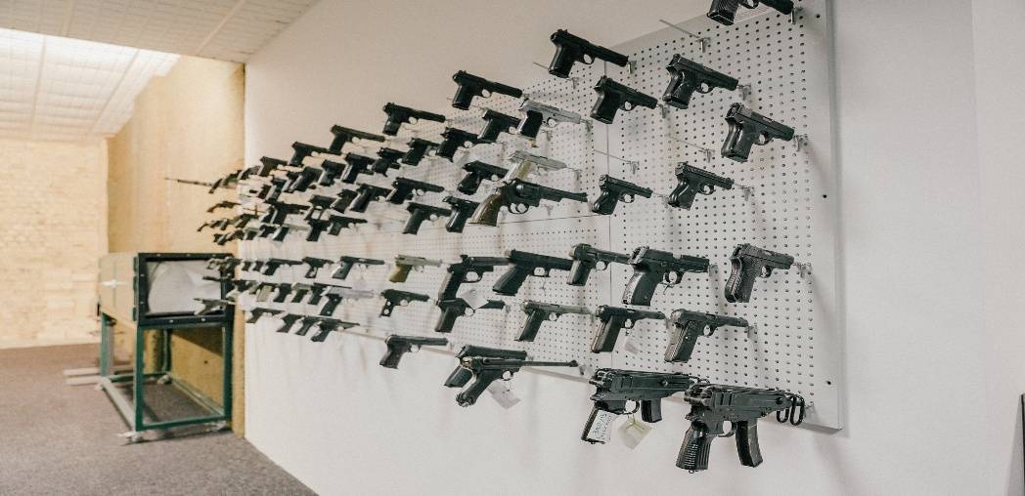

Board for collection of guns – Ballistic lab

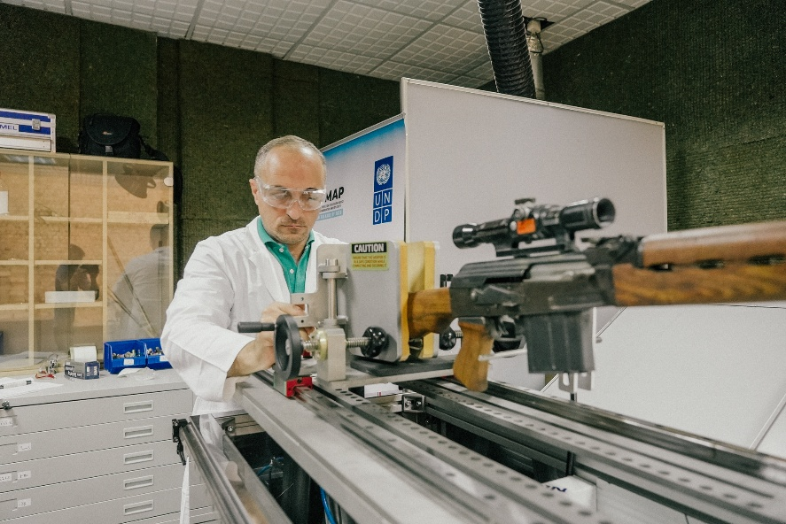

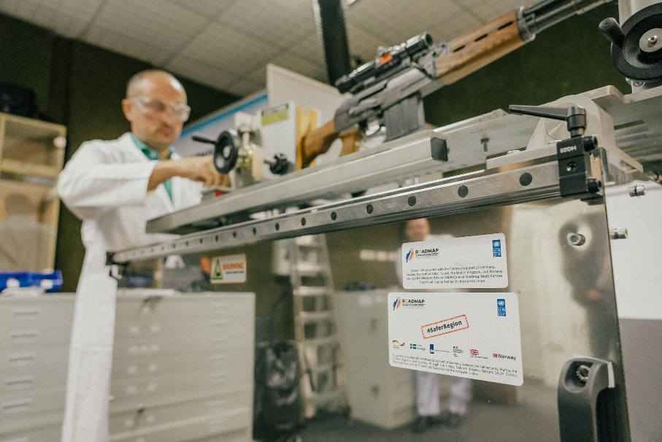

Multifunctional device for safe discharging of firearms – Ballistic lab

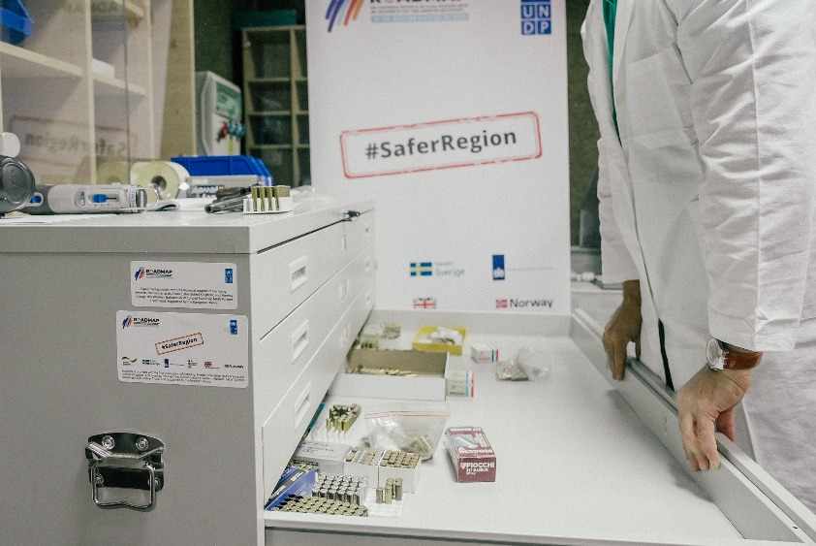
Cabinets for bullet collection – Ballistic lab
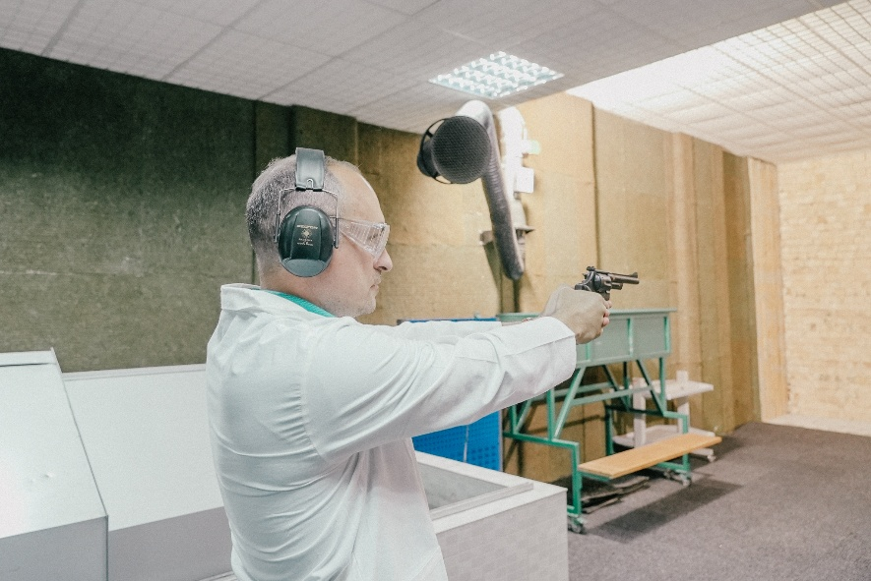

Shooting range – Ballistic lab

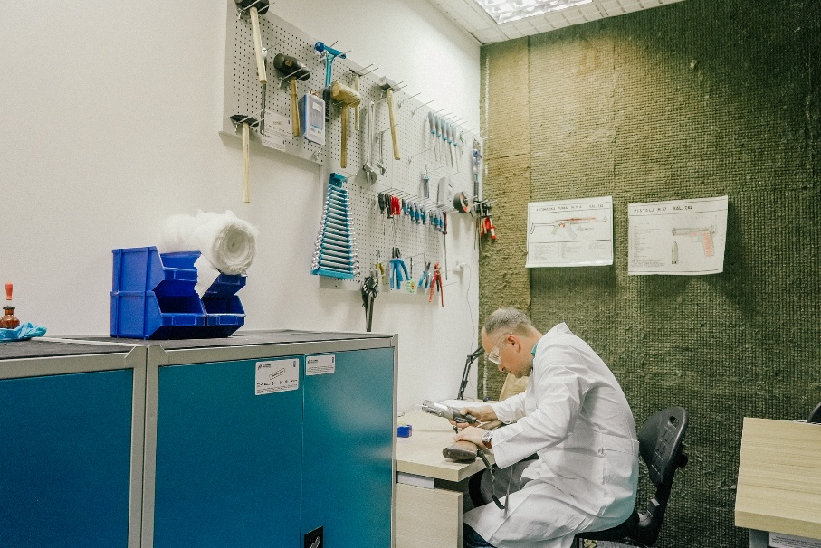

Ballistic workshop

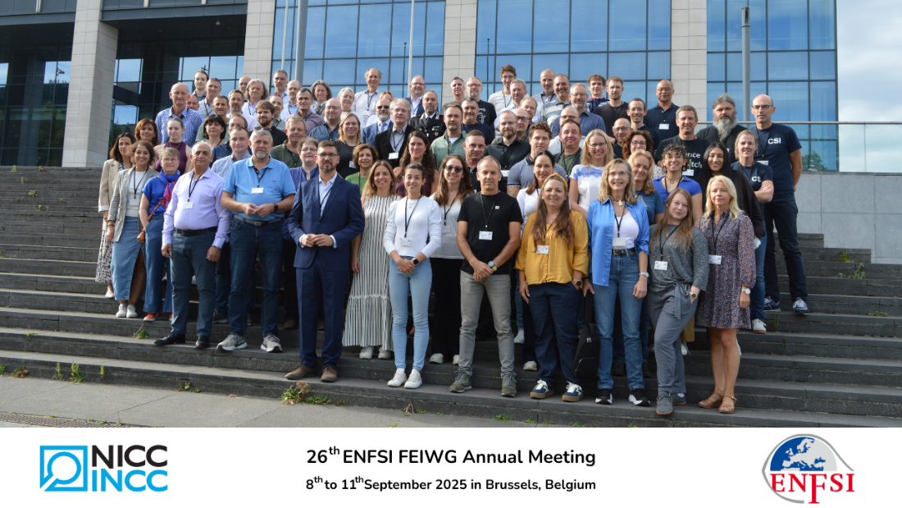

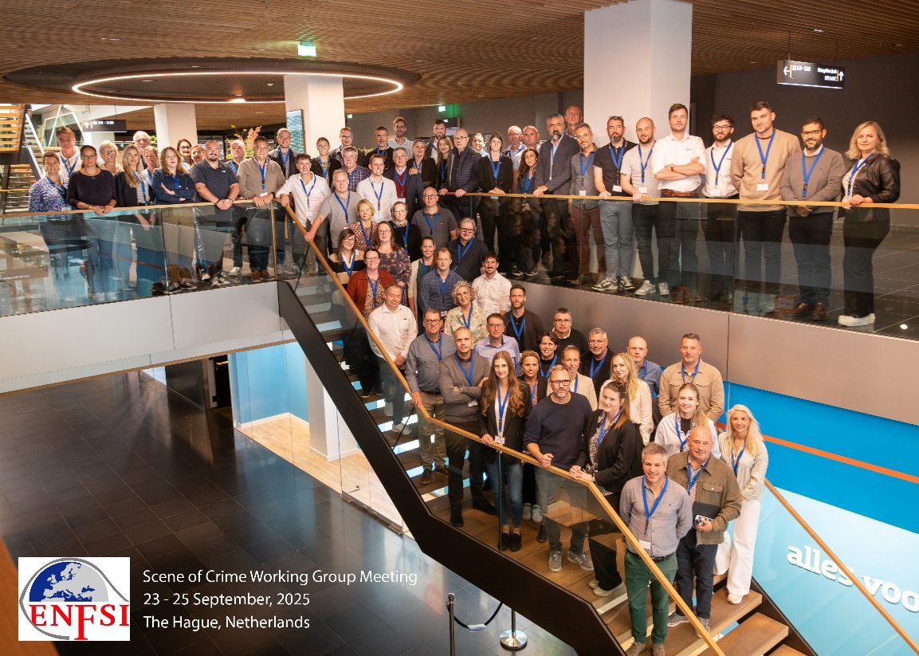

Participation at the ENFSI workshops in Brussels and Hague

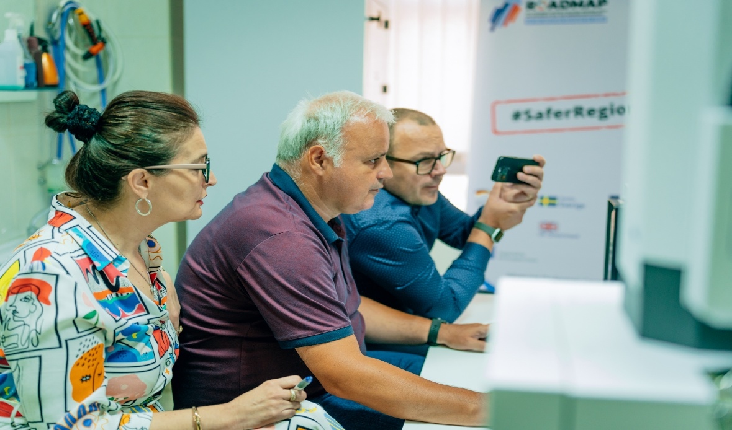

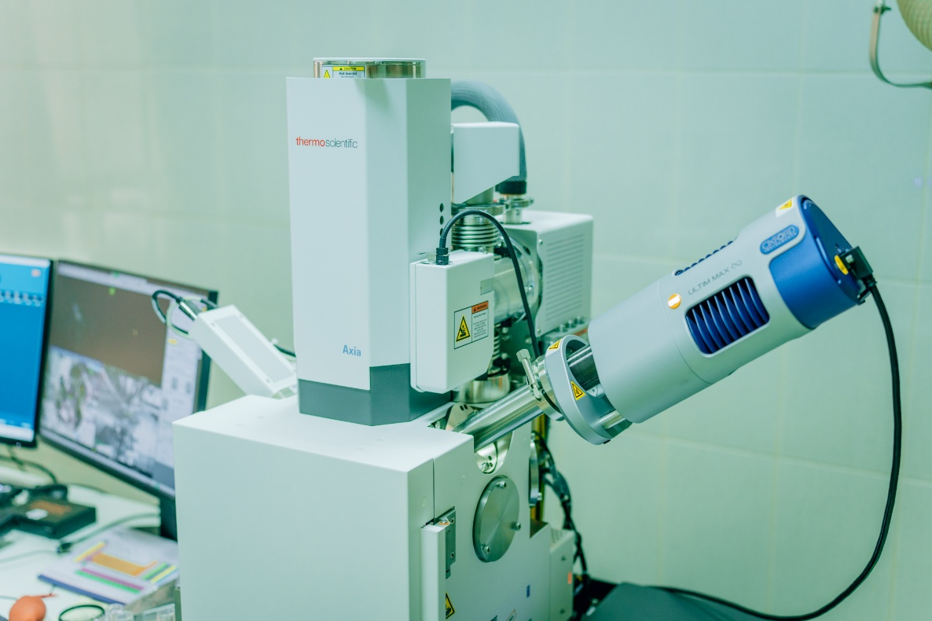

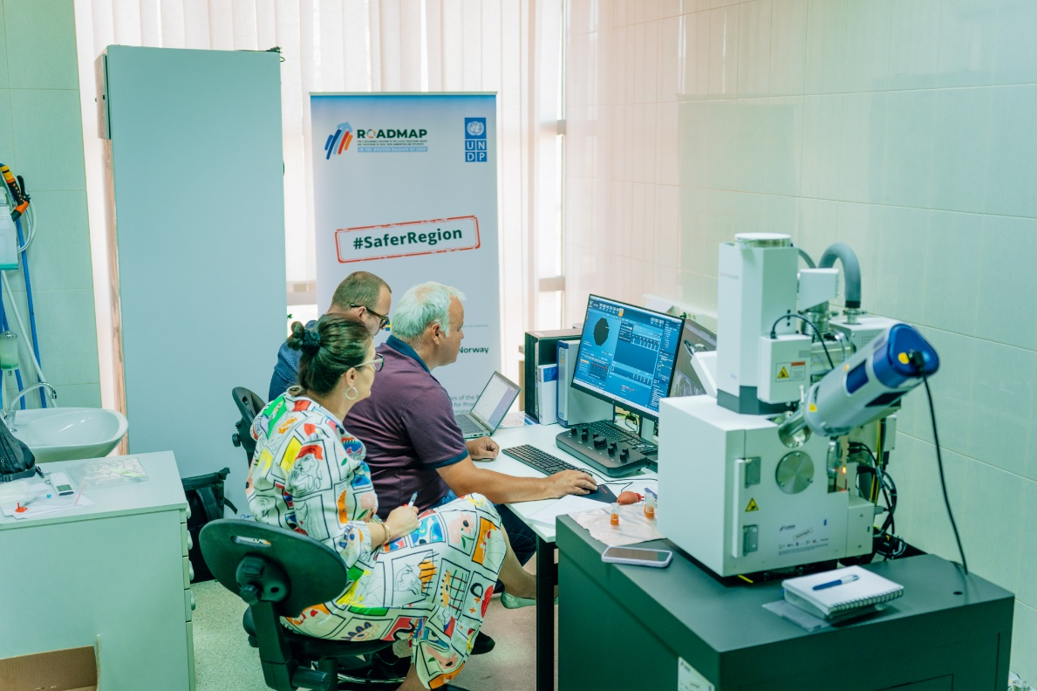

Training on Scanning Microscope delivered conducted by an authorized Thermo-Fisher service provider on the Axia scanning electron microscop

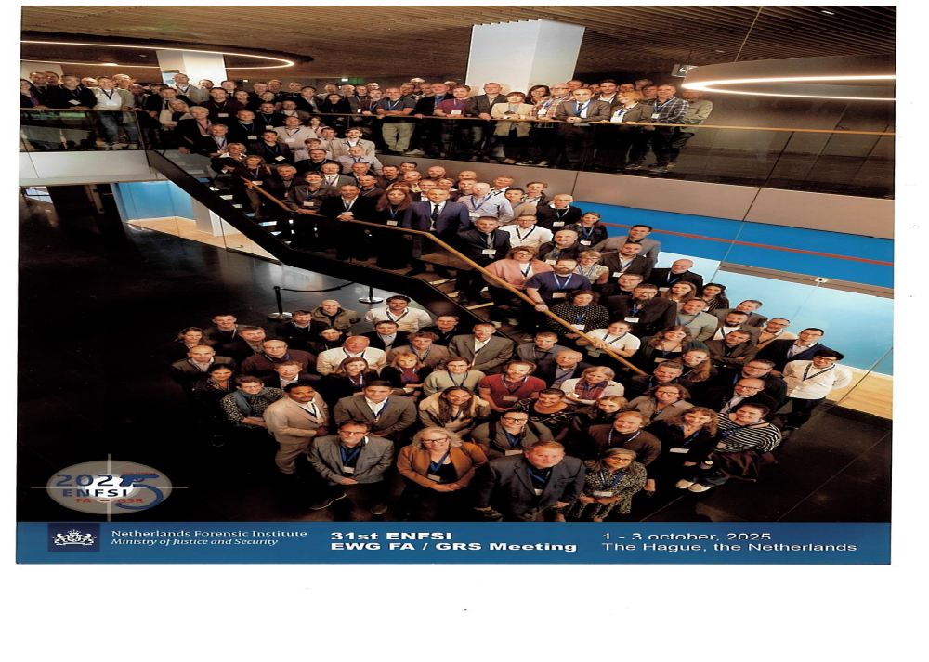

ENFSI workshop in Hague

Specialized training on injury documentation during medical examinations
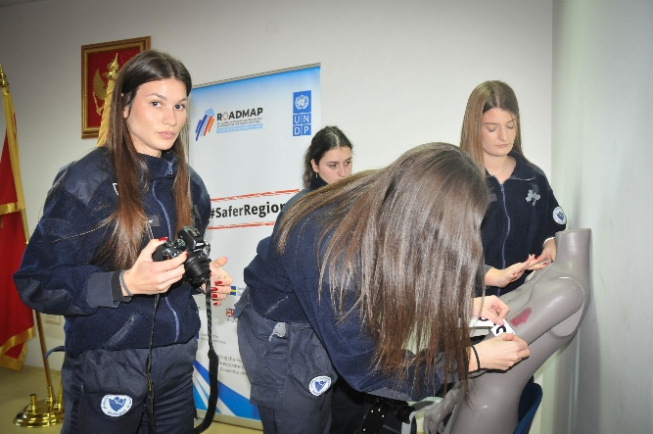

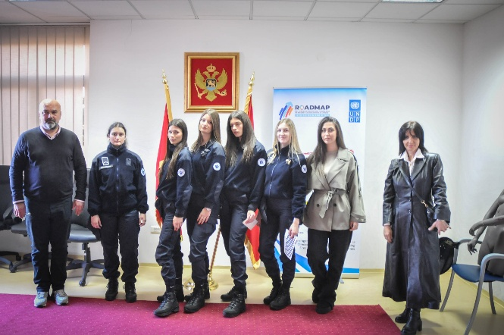
Specialized training on injury documentation during medical examinations

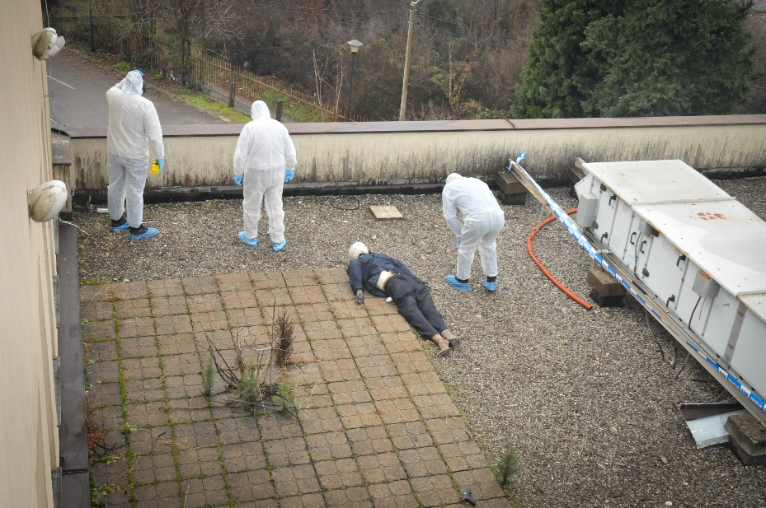
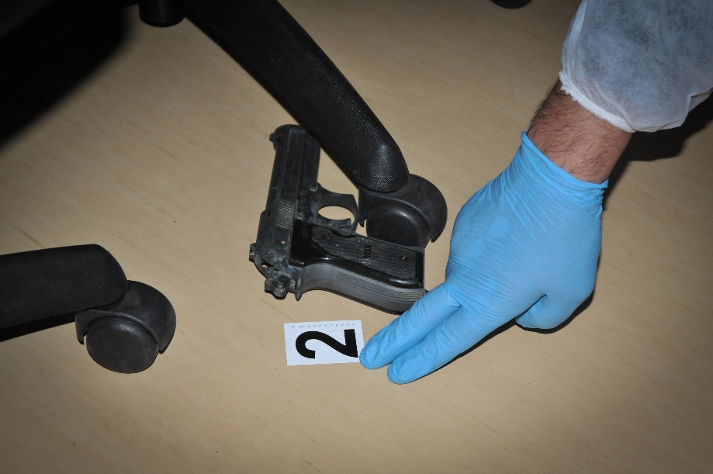
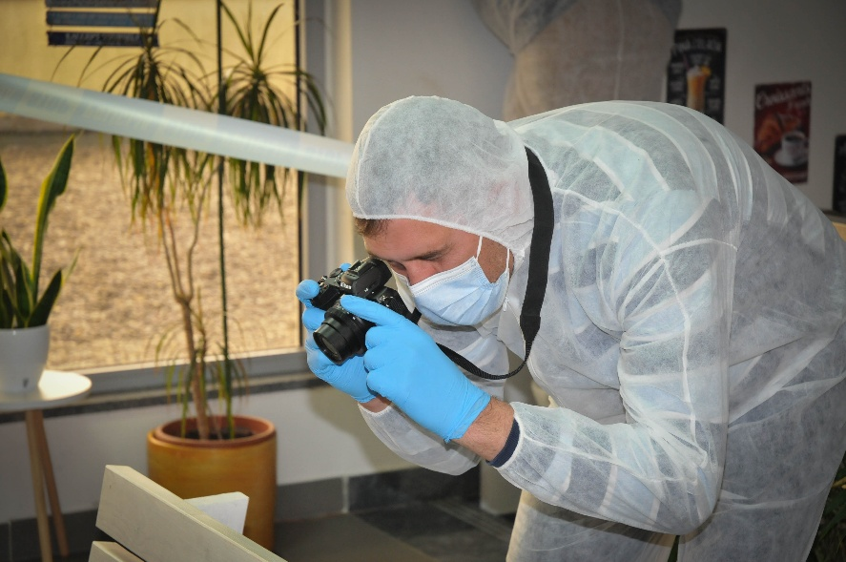

Advanced training in applying ISO/IEC 17020 to crime scene investigation

Strategic Results, as formulated in the Strategic UN Planning Framework (e.g. UNDAF) or project document;
The MPTF Office Project Reference Number is the same number as the one on the Notification message. It is also referred to as “Project ID” on the project’s factsheet page the MPTF Office GATEWAY
The MPTF or JP Contribution, refers to the amount transferred to the Participating UN Organizations, which is available on the MPTF Office GATEWAY
The start date is the date of the first transfer of the funds from the MPTF Office as Administrative Agent. Transfer date is available on the MPTF Office GATEWAY
As per approval of the original project document by the relevant decision-making body/Steering Committee.
If there has been an extension, then the revised, approved end date should be reflected here. If there has been no extension approved, then the current end date is the same as the original end date. The end date is the same as the operational closure date which is when all activities for which a Participating Organization is responsible under an approved MPTF / JP have been completed. As per the MOU, agencies are to notify the MPTF Office when a programme completes its operational activities.
Project: Advancing the capacities of the Police Directorate in the field of custody chain, crime scene investigations and the Forensic laboratory in the field of operations and investigations in detection and trafficking of explosives criminality, implemented in the period January 2021 – October 2023.
The spent amount should cover the period since the beginning of the project until the end of the reporting period.
The spent amount should cover the period since the beginning of the project until the end of the reporting period.
The spent amount should cover the period since the beginning of the project until the end of the reporting period.
The spent amount should cover the period since the beginning of the project until the end of the reporting period.
The spent amount should cover the period since the beginning of the project until the end of the reporting period.
The spent amount should cover the period since the beginning of the project until the end of the reporting period.
The later if applicable.

